JSS MAHAVIDYAPEETHA

### JSS SCIENCE AND TECHNOLOGY UNIVERSITY

**SRI JAYACHAMARAJENDRA COLLEGE OF ENGINEERING**

JSS Technical Institutions Campus, Mysuru – 570006



*Report on*

MINI PROJECT (20EI69P)

*A report on*

# “AUTOMATIC FIRE EXTINGUISHER ROBOT USING IOT”

*by*

### SAGAR P M THEJASWINI C R

(01JST20EI058) (01JST20EI060)

### PRAJWAL S R

(01JST20EI032)

Under the Guidance of

**SHEELA N**

**Assistant professor**

## DEPARTMENT OF ELECTRONICS AND INSTRUMENTATION

SJCE, JSS STU, MYSURU

**JULY 2023**

1. | P a g e

|  |  |  |
| --- | --- | --- |
| **Sl. No** | **Contents** | **Page No** |
| 1 | Introduction | 3 |
| 1.1 | Objectives | 3 |
| 2 | Methodology | 5 |
| 2.2 | Hardware Description | 6 |
| 2.3 | Software Requirements | 13 |
| 3 | Algorithm |  |
| 4 | Result | 17 |
| 5 | Conclusion | 18 |

# 1. INTRODUCTION:

Machinery and robotic design become important in helping human. Fire Protection Robot was design to help people in any destructive burnt situation where this robot can extinguish burnt area immediately using autonomous system This autonomous system will be designed using programming in Arduino mega 2560 and others additional circuit. Sense fire,smoke and temperature at the site of disaster by using 8 array IR sensors mounted on the robot. If fire is detected with the help of sensors , Arduino mega and relay operates water pump mechanism Destructive burnt area often happens without our realization. This type of robot will require a high demands in the market because of its usefulness to the human as well as the environment purpose. The security of home, laboratory, office, factory and building is important to human life. We develop security system that contains a fire protection robot using sensor. The security system can detect abnormal and dangerous situation and notify us. The fire difficulties to detect the small burnt area and location that is hard to be reach by the user.

# 1.1 OBJECTIVES:

* To detect fire in the disaster prone area.
* Extinguishes fire on detection.
* Reduces the efforts of human labour and level of destruction.
* Robot can detect burnt area in 0m ~ 1m radius.

1. | P a g e

# 2. METHODOLOGY:

## BLOCK DIAGRAM:

The below fig a shows the complete circuit diagram of fire extinguisher robot including few components like UV Sensor, IR Sensor, Temperature sensor, Wifi module, Arduino mega and Node MUC.

**TEMPERATURE SENSOR**

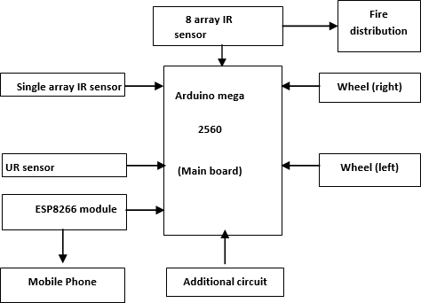

**Fig.a BLOCK DIAGRAM**

1. | P a g e

.

## HARDWARE DESCRIPTION:

### 2.2.1 ARDUINO MEGA 2560:

The Arduino Mega 2560 is a microcontroller board based on the ATMEGA2560. It has 54 digital input/output pins (of which 15 can be used as PWM outputs), 16 analog inputs, 4 UARTs (hardware serial ports), a 16 MHz crystal oscillator, a USB connection, a power jack, an ICSP header, and a reset button. It contains everything needed to support the microcontroller; simply connect it to a computer with a USB cable or power it with a AC- to-DC adapter or battery to get started.

### 

### Specifications:

* Microcontroller: ATmega2560
* Operating Voltage: 5V
* Digital I/O Pins: 54 (of which 15 provide PWM output)
* Analog Input Pins: 16
* Flash Memory: 256 KB.
* SRAM: 8 KB
* UART: 4 (Hardware Serial ports)
* SPI: 1
* I2C: 1

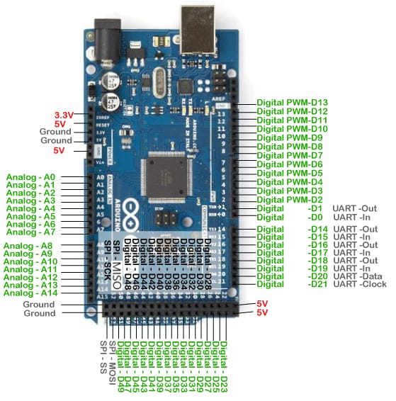

Fig.a ARDUINO MEGA 2560

**2.2.2 ESP8266 Wi-Fi Module:**

An ESP8266 Wi-Fi module is a SOC microchip mainly used for the development of end-point IoT ([Internet of things](https://www.elprocus.com/future-technology-internet-of-things/)) applications. It is referred to as a standalone wireless transceiver, available at a very low price. It is used to enable the internet connection to various applications of embedded systems. Express if systems designed the ESP8266 Wi-Fi module to support both the TCP/IP capability and the microcontroller access to any Wi-Fi network. It provides the solutions to meet the requirements of industries of IoT such as cost, power.

### Specifications:

### Microcontroller: Tensilica L106 32-bit RISC microcontroller unit (MCU).

### Wi-Fi Connectivity: IEEE 802.11 b/g/n Wi-Fi standards.

### Communication Interfaces: UART (Universal Asynchronous Receiver-Transmitter) .

### SPI (Serial Peripheral Interface): For interfacing with external devices.

### I2C (Inter-Integrated Circuit): For connecting to sensors and peripherals.

### Operating Voltage: Operates at 3.3V.

### ADC (Analog-to-Digital Converter): The ADC resolution is typically 10 bits.

### 

### 

### Fig.b ESP8266 Wi-Fi ModuleBottom of Form

**2.2.3 8 ARRAY IR SENSOR:**

An 8-array IR sensor consists of infrared emitters and detectors. The emitters emit infrared light, which gets reflected by objects. The detectors detect the reflected infrared light and generate electrical signals. These signals are processed to determine the presence, absence, or movement of objects. The sensor provides spatial information and can be used for motion detection, proximity sensing, and object tracking.

This sensor module has 8 IR LED/phototransistor pairs mounted on a 0.375" pitch, making it a great detector for a line-following robot. Pairs of LEDs are arranged in series to halve current consumption, and a MOSFET allows the LEDs to be turned off for additional sensing or power-savings options. Each sensor provides a separate analog voltage output.

**Specifications:**

* Number of Arrays: 8
* Operating Voltage: 3.3V to 5V
* Output Type: Digital or Analog
* Communication Interface: I2C or UART, for connecting with other devices.

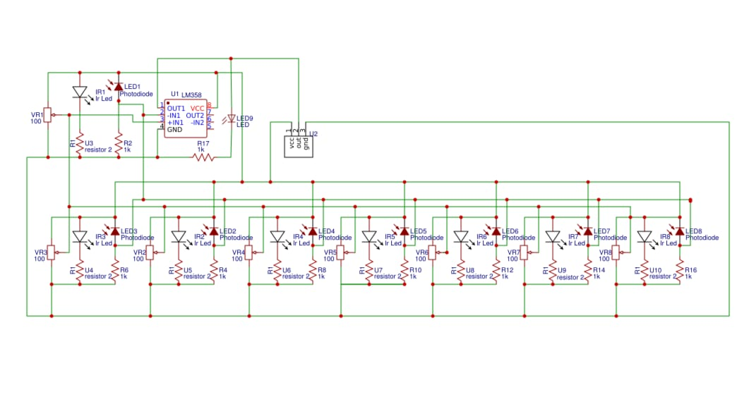 Fig.c 8 ARRAY IR SENSOR

# 2.2.4 TEMPERATURE SENSOR (DHT11):

# The DHT11 temperature sensor measures temperature and humidity. It uses a thermistor and humidity sensor for sensing. The analog signals are converted into digital using an ADC. The data is transmitted serially to a microcontroller. The microcontroller decodes the data and provides temperature and humidity values.

The DHT11 is a basic, ultra low-cost digital temperature and humidity sensor. It uses a capacitive humidity sensor and a thermistor to measure the surrounding air, and spits out a digital signal on the data pin (no analog input pins needed). Its fairly simple to use, but requires careful timing to grab data.

**Specifications:**

# Temperature Measurement Range: 0°C to 50°C (32°F to 122°F).

# Temperature Measurement Accuracy: ±2°C

# Humidity Measurement Range: 20% to 90% RH

# Operating Voltage: 3.3V to 5V

# Sampling Rate: 1 reading per 2 seconds.

# Temperature Sensor Circuit using Thermistor

# Fig.d TEMPERATURE SENSOR (DHT11)

# 2.2.5 5V RELAY:

# A 5v relay is an automatic [switch](https://www.elprocus.com/what-is-a-centrifugal-switch-and-its-working/) that is commonly used in an automatic control circuit and to control a high-current using a low-current signal. The input voltage of the relay signal ranges from 0 to 5V. It is an electromagnetic switch that operates using a 5V DC power supply. It consists of a coil and a set of contacts. When the coil is energized with a 5V signal, it creates a magnetic field that attracts the contacts, closing or opening the circuit.

Fig.e 5V RELAY

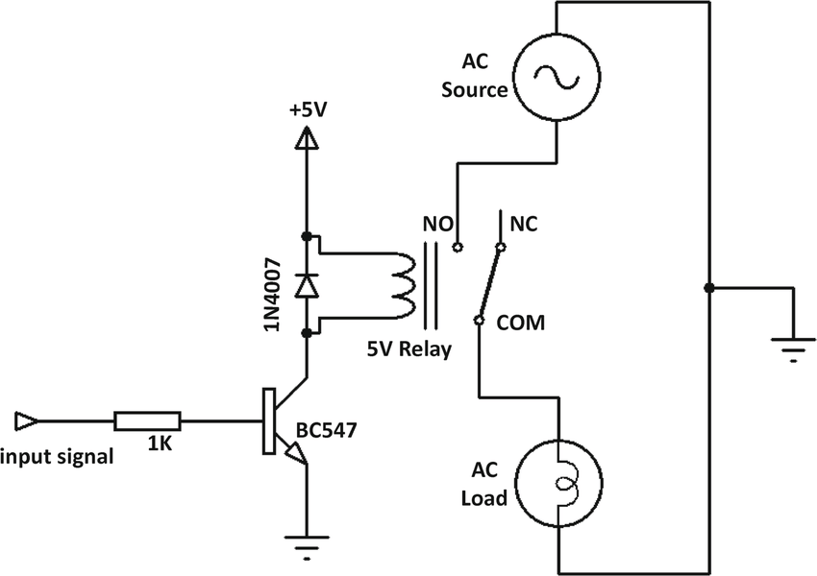

CIRCUIT DIAGRAM FOR REALY

# 2.2.6 BUCK CONVERTER:

A buck converter, or step-down converter, reduces a higher DC voltage to a lower DC voltage. It utilizes a power switch, inductor, and capacitor to transfer energy. The switch rapidly turns on and off, controlling the energy flow. The output voltage is regulated by adjusting the switch's duty cycle. Feedback control maintains the desired output voltage. Buck converters are efficient and widely used in electronics for voltage conversion.

It is a [DC-to-DC converter](https://en.wikipedia.org/wiki/DC-to-DC_converter) which steps down voltage (while stepping up current) from its input (supply) to its output (load). It is a class of [switched-mode power supply](https://en.wikipedia.org/wiki/Switched-mode_power_supply). Switching converters (such as buck converters) provide much greater [power efficiency](https://en.wikipedia.org/wiki/Power_efficiency) as DC-to-DC converters than [linear regulators](https://en.wikipedia.org/wiki/Linear_regulator), which are simpler circuits that lower voltages by dissipating power as heat, but do not step up output current.

# 

# Fig.f BUCK CONVERTER

# 12v to 5v dc-dc converter circuit diagram | CircuitsTune

# CIRCUIT DIAGRAM FOR BUCK CONVERTER

# 

**2.2.7 9V SUBMERSIBLE PUMP:**

A typical 9V submersible pump operates underwater using a 9V DC power source. It has a flow rate ranging from around 200 L/h to 1000 L/h, depending on the model. The pump is designed to lift water to a maximum head height of a few meters. It is suitable for applications like aquariums, water features, and hydroponics. The maximum submersion depth should be followed as per the manufacturer's guidelines for safe operation.

**Specifications:**

* Voltage: 9 volts DC power supply.
* Flow Rate: 120 liters per hour.
* Operating Temperature Range: 32F to 104F.
* 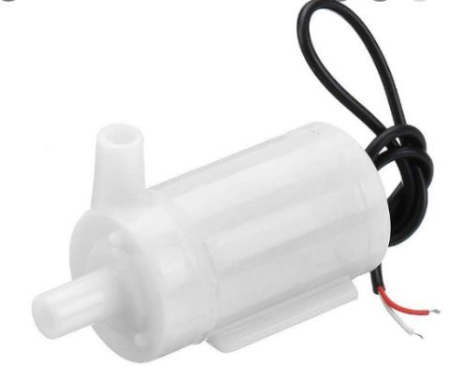Noise Level: 40 to 60 (Db)

Fig.f 9V SUBMERSIBLE PUMP

**2.2.8 ULTRA SONIC SENSOR:**The **HC-SR04 Ultrasonic (US) sensor** is a 4 pin module, whose pin names are Vcc, Trigger, Echo and Ground respectively. This sensor is a very popular sensor used in many applications where measuring distance or sensing objects are required. The module has two eyes like projects in the front which forms the Ultrasonic transmitter and Receiver. The sensor works with the simple high school formula that

**Distance = Speed × Time**

The Ultrasonic transmitter transmits an ultrasonic wave, this wave travels in air and when it gets objected by any material it gets reflected back toward the sensor this reflected wave is observed by the Ultrasonic receiver module

**SPECIFICATIONS:**

* Operating voltage: +5V
* Theoretical Measuring Distance: 2cm to 450cm
* Practical Measuring Distance: 2cm to 80cm
* Accuracy: 3mm
* Measuring angle covered: <15°
* Operating Current: <15mA
* Operating Frequency: 40Hz

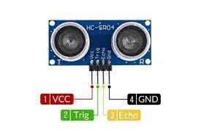

Fig.g UR SENSOR

**2.2.9 MOTOR DRIVER MODULE:**

This L298N Motor Driver Module is a high power motor driver module for driving DC and Stepper Motors. This module consists of an L298 motor driver IC and a 78M05 5V regulator. L298N Module can control up to 4 DC motors, or 2 DC motors with directional and speed control.

|  |  |
| --- | --- |
| **Pin Name** | **Description** |
| IN1 & IN2 | Motor A input pins. Used to control the spinning direction of Motor A |
| IN3 & IN4 | Motor B input pins. Used to control the spinning direction of Motor B |
| ENA | Enables PWM signal for Motor A |
| ENB | Enables PWM signal for Motor B |
| OUT1 & OUT2 | Output pins of Motor A |
| OUT3 & OUT4 | Output pins of Motor B |
| 12V | 12V input from DC power Source |
| 5V | Supplies power for the switching logic circuitry inside L298N IC |
| GND | Ground pin |

### ****L298N Module Pinout Configuration****

### 

### ****Features & Specifications****

* Driver Model: L298N 2A
* Driver Chip: Double H Bridge L298N
* Motor Supply Voltage (Maximum): 46V
* Motor Supply Current (Maximum): 2A
* Logic Voltage: 5V
* Driver Voltage: 5-35V
* Driver Current:2A
* Logical Current:0-36mA
* Maximum Power (W): 25W
* Current Sense for each motor
* Heatsink for better performance
* Power-On LED indicator

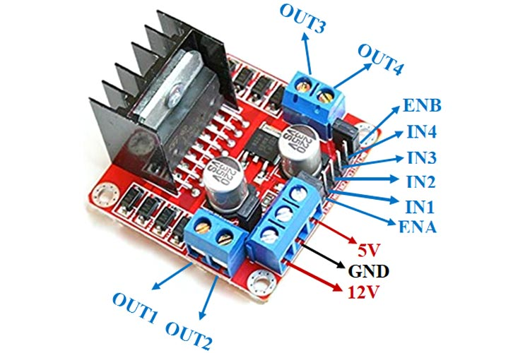

Fig.h MOTOR DRIVER MODULE

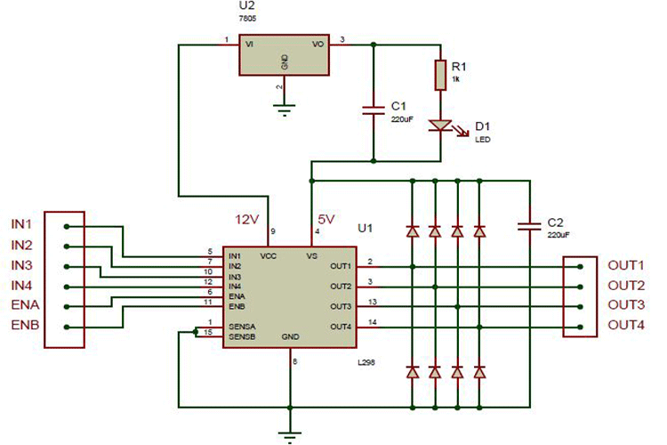

Fig.I CIRCUIT DIAGRAM FOR MOTOR DRIVER

**2.3. SOFTWARE REQUIREMENTS**:

**2.3.1. Arduino IDE:**

The Arduino IDE is an open-source software, which is used to write and upload code to the Arduino boards. The IDE application is suitable for different operating systems such as Windows, Mac OS X, and Linux. It supports the programming languages C and C++. Here, IDE stands for Integrated Development Environment. The program or code written in the Arduino IDE is often called as sketching. The IDE supports various Arduino boards and offers a serial monitor for debugging. Code can be uploaded via USB, and the IDE is open-source with a strong community for support and resources.



Arduino IDE

### 2.3.2 Blynk:

 Blynk is a Platform with IOS and Android apps to control Arduino, Raspberry Pi and the likes over the Internet. It’s a digital dashboard where you can build a graphic interface for your project by simply dragging and dropping widgets. Blynk is a new platform that allows you to quickly build interfaces for controlling and monitoring your hardware projects from your iOS and Android device. After downloading the Blynk app, you can create a project dashboard and arrange buttons, sliders, graphs, and other widgets onto the screen.

Blynk logo

**3. ALGORITHM:**

1. Start

2. Initialize the Wire.h and LiquidCrystal_I2C.h.

3. Set up the Arduino board:

- Initialize the LCD display and backlight.

- Set pin modes for motor control, sensor inputs, ultrasonic sensor pins, and necessary pins.

- Start serial communication.

4. Enter the main loop:

- Read analog inputs (A0-A7) and digital inputs (50, 51).

- Print the values to the Serial Monitor.

5. Check if the FireBot is in Auto or Manual mode (nm1):

- If nm1 is LOW (Auto mode):

- Display FireBot Auto on the LCD.

- Check fire alarm conditions:

- Check if any of the fire alarm conditions are met (digital inputs or analog inputs).

- If a fire alarm is detected:

- Set pin 46 LOW (Activate fire alarm indicator).

- If no fire alarm is detected:

- Set pin 46 HIGH (Deactivate fire alarm indicator).

- If nm1 is HIGH (Manual mode):

- Display "FireBot Manual" on the LCD.

- Check if the manual stop button is pressed (nm6):

- If nm6 is HIGH (Manual stop button pressed):

- Set pin 46 LOW (Stop the FireBot).

- If nm6 is LOW (Manual stop button not pressed):

- Set pin 46 HIGH (Allow FireBot movement).

- Check the control buttons (nm2, nm3, nm4, nm5) for movement instructions:

- If nm2 is HIGH (Forward button pressed):

- Move the FireBot forward by calling the forward() function.

- Display "Forward" on the LCD.

- If nm3 is HIGH (Right button pressed):

- Make the FireBot turn right by calling the right() function.

- Display "Right" on the LCD.

- If nm4 is HIGH (Reverse button pressed):

- Move the FireBot backward by calling the reverse() function.

- Display "Reverse" on the LCD.

- If nm5 is HIGH (Left button pressed):

- Make the FireBot turn left by calling the left() function.

- Display "Left" on the LCD.

- If none of the buttons are pressed:

- Halt the FireBot by calling the halt() function.

6.End

**4.RESULTS**:

The robot can detect fire from a distance and can extinguish fire both automatic and manually.

It has the potential to reduce human error and limitations associated with fire extinguishing tasks.

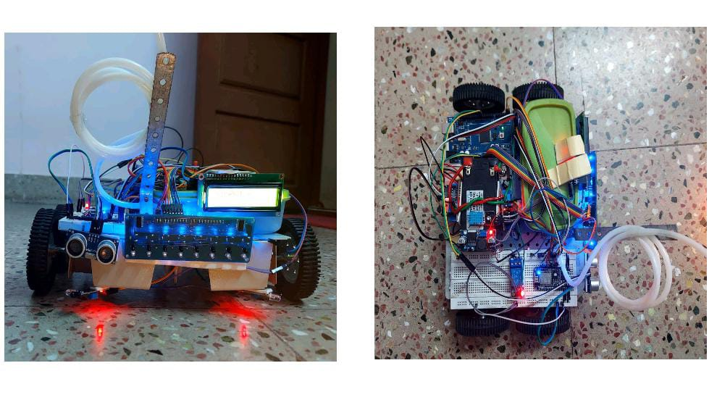

Figure 4: Demonstration of the project

**5.CONCLUSION:**

It has advantageous features such as the ability to detect the source of fire, extinguishing it and increase the knowledge about fire behavior from the incident area. With the common digitalized platform, these instrument will enable increased flexibility in control and operation.

.

**5.CONCLUSION:**

It has advantageous features such as the ability to detect the source of fire, extinguishing it and increase the knowledge about fire behavior from the incident area.

With the common digitalized platform, these instrument will enable increased flexibility in control and operation.

Future scope:

Fixing the camera for better visualization.

Rotating the water tube.

Use of buzzer or siren for indication of fire.

Developing own application for operation.

1. | P a g e
2. | P a g e
3. | P a g e
4. | P a g e
5. | P a g e